**Project Documentation**

What software Eng SE ?

* state of the art of developing quality software on time and

within budget

* Trade-off between perfection and physical constraints
* SE has to deal with real-world issues
* State of the art!
* Community decides on best practice + life-long education

What are **SDLC**( software dev life cycle ) & its rules?

* For project development rules & regulation need to be followed for best quality output at defined time limit
* Rules are Software Development Life Cycle – SDLC
* It‘s part of software engineering
* Six rules to be followed…

Project Rules & Regulation (SDLC) Software deve life cycle

6 RULES

1. **Requirement**
2. **Analysis**

Requirement analysis

Time requirement

Budget

How many users

**Step 1: How many user work on website**

* 1. Guest
  2. Customer Website

* 1. Admin admin panel
  2. Employee employee panel

===============================================================

Step 2: Define work of each user

* 1. Guest

Website visit

View product categories

View product

Contact us

* 1. Customer

**Website visit**

**View product categories**

**View product**

**Contact us**

**Signup**

**Login**

**Manage profile**

**Add to cart**

**Make Order**

**Manage order**

**Feedback**

**Logout**

===== Backend Panel

Login.php index

Dashboard

Table PAGE - All manage task

FORM PAGE – all add task

================== ONLY 4 PAGES

* 1. Employee

Signup by admin

Login

Manage product categories add / upd / del T/F

Manage product

Manage Contact us

Manage Customer

View cart report

Manage Order

View Feedback

Logout

* 1. Admin

Login login

Manage product categories add upd del T/F

Manage product T/F

Manage Contact us T

Manage Customer T

View cart report T

Manage Order T

View Feedback T

Manage Employee T/F

Logout

Step 3: Define panel by user

Website: Guest / Customer

Employee panel: Employee

Admin Panel: Admin

50% planning clear

====================================================

Step 4: Define Some Diagram

1. Use case Diagram

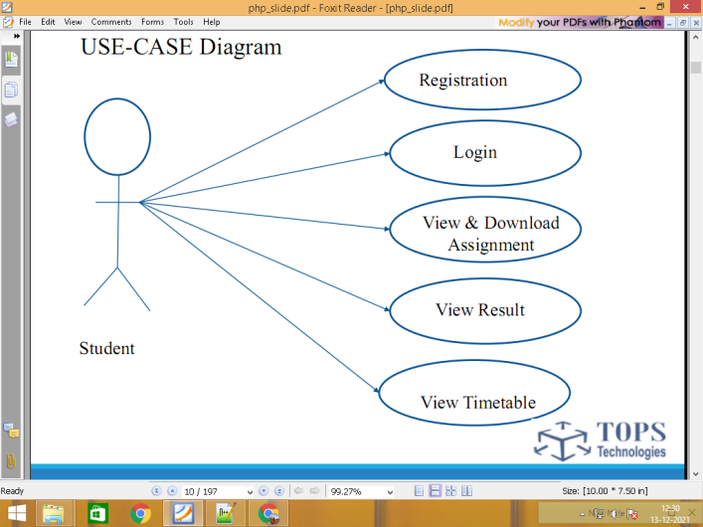

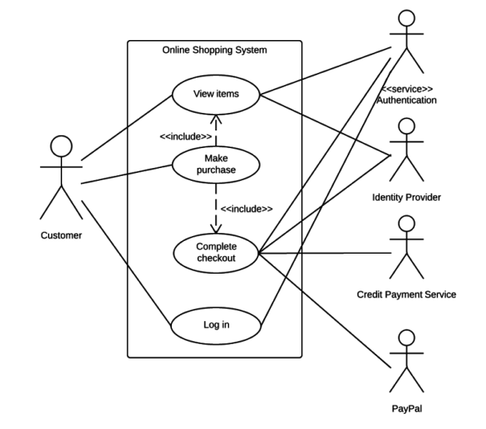

1. DFD Data flow diagram level 0 / 1 / 2

0 level / context level diagram

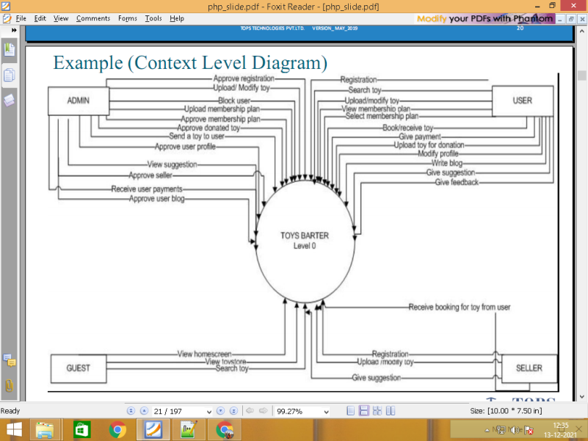

Level 1

\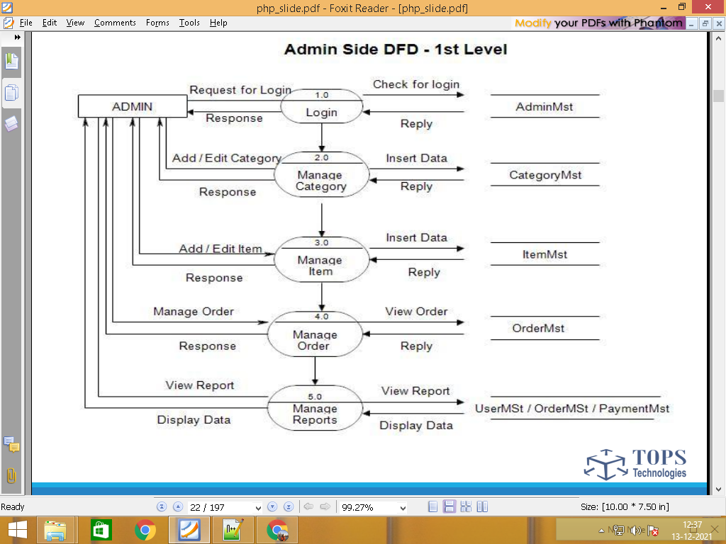

Website visit

Guest View product categories categories.tbl

View product products.tbl

Contact us contacts.tbl

Website visit

View product categories categories.tbl

View product products.tbl

Contact us contacts.tbl

Signup customers.tbl

Customer Login customers.tbl

Manage profile customers.tbl

Add to cart carts.tbl

Make Order orders.tbl

Manage order orders.tbl

Feedback feedbacks.tbl

Logout customers.tbl

Signup by admin employees.tbl

Login employees.tbl

Manage product categories categories.tbl

Manage product products.tbl

Manage Contact us contacts.tbl

Employee Manage Customer customers.tbl

View cart report carts.tbl

Manage Order orders.tbl

View Feedback feedbacks.tbl

Logout employees.tbl

Login admin.tbl LF

Manage product categories categories.tbl T - F

Manage product products.tbl T -F

Manage Contact us contacts.tbl T

Admin Manage Customer customers.tbl T

View cart report carts.tbl T

Manage Order orders.tbl T

View Feedback feedbacks.tbl T

Manage Employee employees.tbl F -T

Logout admin.tbl

**=====================================================================================**

Step 5: Define Total No. of Table List

admin.tbl

categories.tbl

products.tbl

contacts.tbl

customers.tbl

carts.tbl

orders.tbl

feedbacks.tbl

employees.tbl

Step 6 : Define Each table column / Data Dictionary

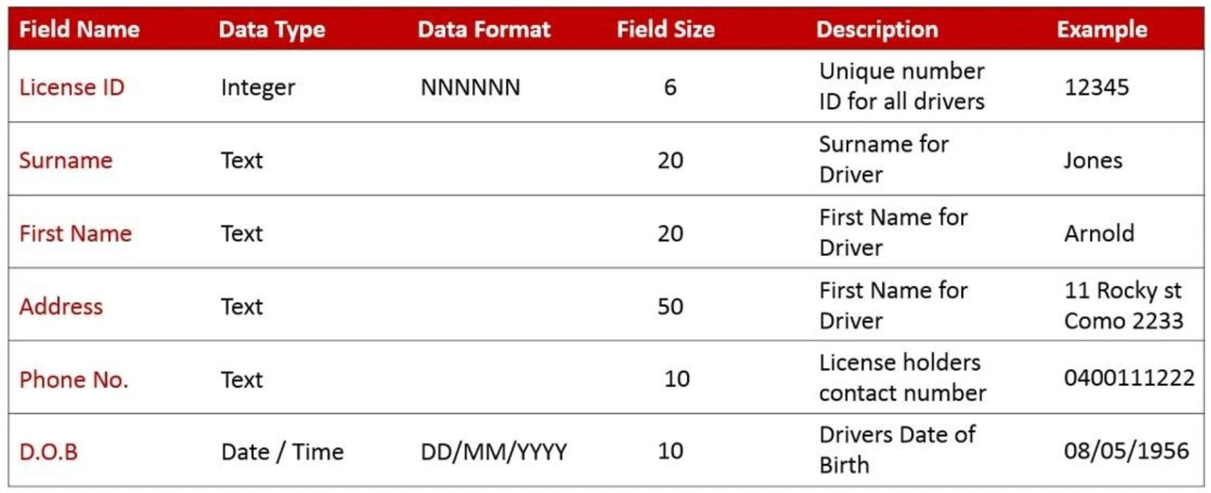

admin.tbl login 2 form

**id pk auto_increement**

name

email

password

categories.tbl column : 3 / form : 2

**id pk auto_increement 1**

name khakhara

image **khakhara.jpg**

10 categories

subcategories form 3 / column 4

**id pk auto_increement**

cate_id fk

sub_catename

sub_cateimage

products.tbl

**id pk auto_increement**

cate_id fk

subcate_id fk

prod_name

short_desc

long_desc

main_price

disc_price

prod_image

**status**

contacts.tbl column 4 / form 3

**id pk auto_increement**

name

email

comment

customers.tbl signup form 5 / table column 7

**id pk auto_increement**

name

email

password

mobile

image

**status automatic**

carts.tbl

**id pk auto_increement**

prod_id fk

cust_id fk

qty

total_price

orders.tbl

**id pk auto_increement**

cart_id fk

cust_id fk

total_amout

address

state

city

pincode

feedbacks.tbl

**id pk auto_increement**

order_id fk

cust_id fk

comment

employees.tbl

**id pk auto_increement**

name

email

password

**status**

**============================================================**

1. Designing

Database & table create / website designing

1. Implementation/coding

Data add / update / delete code

1. Testing

Website works without bugs or error

Testing

1. Maintenance

User guide

Installation

After maintenance service

Any changes & updating

================================================

Page layout ADMIN / employee

Login.php

Dashboard

Add_task form

Manage table

Free css admin panel

MENU

1 ADD-MANAGE => DROPDOWN

2 MANAGE => SIMLE LINK WALA MENU